***Investigating Improved ……………………….***

**Etim …………….**

………………………………………………….

2Department of …………….., Misurata University

*Corresponding author:……………………@sci.misuratau.edu.ly

Submission data 21 . 2.2022 Acceptance data 28. 2 .2022 Electronic publisher data: 1.3.2022

**Abstract:** Primary production mechanisms do not recover an appreciable ……………………………… ………………………………………………………………………..

**Keywords**: Heavy, Oil, Recovery, Reservoir, Production, Simulation

**Introduction:**

Improved oil recovery processes broadly encompass all of the measures aimed towards increasing ultimate recovery from a petroleum reservoir. Most reservoirs are subjected to improved oil recovery (IOR) processes following primary recovery. Natural reservoir energies control the ultimate recovery of petroleum during primary production; such drive mechanisms include liquid and rock compressibility drive, solution gas drive, gas-cap drive, natural water influx, and combination drive processes[1]. Primary recovery from oil reservoirs is influenced by reservoir rock properties, fluid properties, and geologic …………………...

**Model Description**

The numerical model used in this study is basically ………………..

**Simulation Scenarios**

GEM was used to model different improved-oil-recovery situations --- water, gas and water-alternating-gas injection mechanisms. Each simulation run is done for a production time span of 20 years, and the cardinal production variables (oil production rate, cumulative oil production, water cut, cumulative gas-oil ratio, flowing bott-omhole pressure, and average reservoir pressure) are examined. It is assumed that there is no permeability alteration in the vicinity of the producing wells; hence no skin factor is set to zero in each production scenario.

Each simulation run is dedicated to a specific production technique that combines a production well and an injection well. The objective of each run is to evaluate how the injection sustains and improves recovery at the production well. Both the production and injection well are controlled by a set of constraints aimed to keep production going for as long as possible and hence raise the levels of cumulative oil production. Table – 2 indicates the constraints set on the production and injection wells.

**Case 1: Vertical Production Well**

This is the base case with which the rest cases are compared. It consists of just a

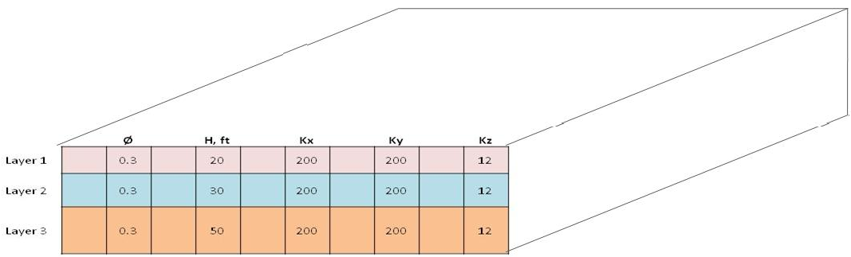

Fig. 1 Reservoir system

Table 1 Reservoir rock and fluid properties



**References:**

1. Z. Rui et al., “A quantitative oil and gas res-erveoir evaluation system for development,” J. Nat. Gas Sci. Eng., vol. 42, 2017, doi: 10.1016/j.jngse. 2017.02.026.
2. A. Mohsenatabar Firozjaii and H. Saghafi, “Review on chemical enhanced oil recovery using polymer flooding: Fundamentals, exp-erimental and numerical simulation,” Petro-leum, vol. 6, no. 2. 2020.
3. E. C. Donaldson, G. V. Chilingarian, and T. F. Yen, “Enhanced oil recovery, 1: fundam-entals and analyses.,” Enhanc. oil Recover. 1 Fundam. Anal., 1985.
4. S. M. Farouq Ali, “Heavy - oil evermore mobile,” J. Pet. Sci. Eng., vol. 37, no. 1–2, 2003, doi: 10.1016/S0920-4105(02)00307-8.
5. E. Vittoratos, G. R. Scott, and C. I. Beattle, “Cold lake cyclic steam stimulation. A multiwell process,” SPE Reserv. Eng. (Society Pet. Eng., vol. 5, no. 1, 1990, doi: 10.2118/17422-pa.
6. J. Li, T. Jiang, L. P. Xiao, M. Yang, and J. Zhao, “Field study of enhancing oil recovery by gas cycling injection in ultra-deep heavy oil reservoirs,” SPE Asia Pacific Oil Gas Conf. Exhib. 2008 - "Gas Now Deliv. Expect., vol. 2, pp. 931–937, 2008, doi: 10.2118/ 115877-ms.
7. S. Huang, S. Ali, and S. Dyer, “PROTOT-YPE SASKATCHEWAN HEAVY OILS WITH CARBON DIOXIDE BEHAVIOUR AND SCALED MODEL STUDIES OF PROTOTYPE SASKAT-CHEWAN HEAV-Y OILS WITH CARBON DIOXIDE THIS PAPER IS TO BE PRESENTED ATTHE FOURTH PETROLEUM CONFERENCE OF,” 1991.
8. D. Lozada and S. Ali, “New sets of scaling criteria for partial equilibrium immiscible carbon dioxide drive,” 1987, doi: 10.2118/ 87-38-23.
9. A. S. Odeh, “COMPARISON OF SOLUTIONS TO A THREE DIMENSION-AL BLACK-OIL RESERVO-IR SIMULA-TION PROBLEM.,” JPT, J. Pet. Technol., vol. 33, no. 1, 1981, doi: 10.2118/9723-pa.